V&V MANUAL TESTING
Mini Project
Hotel Booking Management System

Document Revision History

Date | Revision No. | Author | Summary of Changes
November, 2010 | 1 | Shrilata Tavargeri | Initial Draft
July, 2015 | 1.2 | Shilpa Bhosle | Implemented changes as per integrated syllabus
August, 2016 | 2.0 | Shilpa Bhosle | Implemented changes as per integrated syllabus

Table of Contents
Introduction 4
Setup Checklist 4
Instructions 4
Problem Statement 5
Objective 5
Abstract of the project 5
Functional components of the project 6
Technology used: 7
Implementation 8
Summary of the functionality to be built: 8
Guidelines on the functionality to be built: 9

Introduction
This document outlines a mini project for the V&V Manual Testing LOT. The project is to test an Hotel Booking Management System for an organization. This document contains the work flow of the system and gives guidelines on how to test the functionality gradually in each of the course modules of the V&V Manual Testing LOT.

Setup Checklist
Minimum System Requirements
- Intel Pentium 4 and above Windows XP, 7
- Memory 1 GB
- Internet Explorer 10.0 or higher
- MS Office 2010 Suit or higher
- UNIX Server Connectivity

Instructions
- All the artifacts related to Mini Project, i.e. Requirement Itemization template, Use Cases, Test Cases, TBA template & Defect Report should follow the guidelines.
- Create a directory by your name in drive D. In this directory, create a subdirectory MiniProject<Groupcode>. Store your Project here.
- You can refer to your course material.
- You need to follow the Mini-Project Schedule given in this document.

Problem Statement

Objective

To test Hotel Booking Management System
Abstract of the project

This project is aimed at testing an online Hotel Bookings Management System (HBMS). This is a web based application that can be accessed over the web. This system can be used to search for Hotel rooms and reserve them. This is an integrated system that contains both the user component, Hotel-Employee component and the Admin component.

Use following user credentials to access above given project link.
Username | Password | Role
ilearn | ilearn123 | Admin
edude | edude123 | Employee
sanjay | sanjay123 | Customer

Functional components of the project
Following is a list of functionalities of the system. Wherever, the description of functionality is not adequate, you can make appropriate assumptions and proceed.

There are three categories of people who would access the system viz. customer, hotel-employee & Admin. Each one of them would have some exclusive privileges (for e.g. customer and hotel-employee can just search for hotel rooms and reserve them, but only the admin has the right to add new and modify hotels.)

- Customer and Hotel-Employee should be able to

  - Register into the system.
  - Login to the system using his/her credentials.
  - Search for hotel rooms.
  - Book hotel rooms.
  - View Booking Status

- The Admin should be able to

  - Login to the system using his/her credentials
  - Perform Hotel Management (add/delete/modify Hotel info like description, any special offers etc)
  - Perform Room Management (add/delete/modify Room info like revised tariff)
  - Generate various reports like:
    - View List of Hotels
    - View Bookings of specific hotel
    - View guest list of specific hotel
    - View bookings for specified date

Implementation

Summary of functionalities to be tested:
Sr. No | Course | Duration  (in PDs) | No. of Saturdays | Task Name
1 | Programming Foundation with Pseudo code | 3 | 3 | NA
2 | Web Basics (HTML 5, CSS 3, JavaScript, XML) | 4.5 | 3 | 1. Analyze the given  case study  2. Identifying  requirements from  given case study
3 | Introduction to SE & STLC | 1.5 | 3 | 1. Peer/Group review  of requirements  identified  2. Note  queries related to  requirements found  from given case  study
4 | DBMS/SQL | 4 | 3
5 | UNIX for Users | 2 | 3 | - Peer/Group review of queries  - Closure of queries
6 | Programming Foundation with Pseudo code + Web Basics + OOP & UML + Oracle for Developers Test | 1 | 3 | - Peer/Group review of queries  - Closure of queries
7 | Testing Concepts | 5 | 2 | - Complete Requirement Itemization  - Identify and write Use Cases from the given case study  - Write Test Cases against the requirements identified
8 | Req. Validation Func. Decomposition | 2 | 2
9 | Use cases and use case level test cases | 1 | 2
10 | Testing concepts+Requirement validation+Use case Test | 1 | 2
11 | Task Based Approach | 1 | 2 | - Peer/Group review of Requirement Itemization filled template  - Peer/Group review of Use Cases  - Peer/Group review of Test Cases  - Developing Scenario Matrix from Use Cases  - Make use of TBA template to write UCTC, Form-Level, Field-Level Test Cases
12 | Defect Reporting and Defect Life Cycle Management | 3 | 2
13 | Test Automation and tool basics (Selenium) | 2 | 2
14 | MS Office (MS Word 2010 & MS Excel 2010) | 1 | 2
15 | Task Based Approach + Defect Reporting and Defect Life Cycle Management + Selenium + MS Office 2010 Test | 1 | 2
16 | TMap | 5 | 2 | - Peer/Group review of TBA template  - Execute Test Cases on application  - Log defect in Defect Log template
17 | Test Management Tool | 3 | 2
18 | Non Functional Testing | 2 | 2
19 | Test Driven Development | 1 | 2 | - Execute Test Cases on application  - Log defects in Defect Log template  - Peer/Group review of Defect Log  - Designing Mini-Project presentation
20 | TMap + Test Management Tool + Non Functional Testing + Test Driven Development Test | 1 | 2
21 | Mini Project presentation | 1 |  | Presentation of Mini Project

Guidelines on the functionality to be tested:
- Tables
- Refer the following tables, which were used in this application::
    - Users: This contains the list of valid users with details
    - Hotel: This will contain the list of hotels.
    - RoomDetails: This will contain the details of all the rooms available in all the hotels.
    - BookingDetails: This will contain the list of booked rooms and their details.
- The structure of the above listed tables is as follows:
    - Users: user_id(varchar(4)), password (varchar(7)), role(varchar(10), user_name(varchar (20)), mobile_no(varchar(10)), phone(varchar(10)), address (varchar(25)), email (varchar(15))
    - Hotel: hotel_id(varchar(4)), city (varchar(10)), hotel_name(varchar (20)), address(varchar(25)), description varchar(50)), avg_rate_per-night (number(m,n)), phone_no1(varchar(10)), phone_no2(varchar(10)), rating(varchar(4)), email (varchar(15)), fax (varchar(15))

Note : Description here could be a brief teaser about the hotel like – “Centrally located in the main city centre at Shivajinagar Railway Station, this budget accommodation is designed with spacious rooms…”. It could also give some special offers etc.

    - RoomDetails: hotel_id(varchar(4)), room_id (varchar(4)), room_no(varchar(3)), room_type(varchar(20)), per_night_rate (number(6,2)), availability (Boolean), photo (blob))

Note : Room_type could be Standard non A/C room, Standard A/C room, Executive A/C room, Deluxe A/C room etc.

    - BookingDetails: booking_id(varchar(4)), room_id(varchar(4)), user_id(varchar(4)), booked_from (date), booked_to(date), no_of_adults, no_of_children, amount(number(6,2))

The functionality and components to be tested:

- Application
- Requirement for the application:
- Home page screen: Home page for the online HBMS which provides a link for the login page.

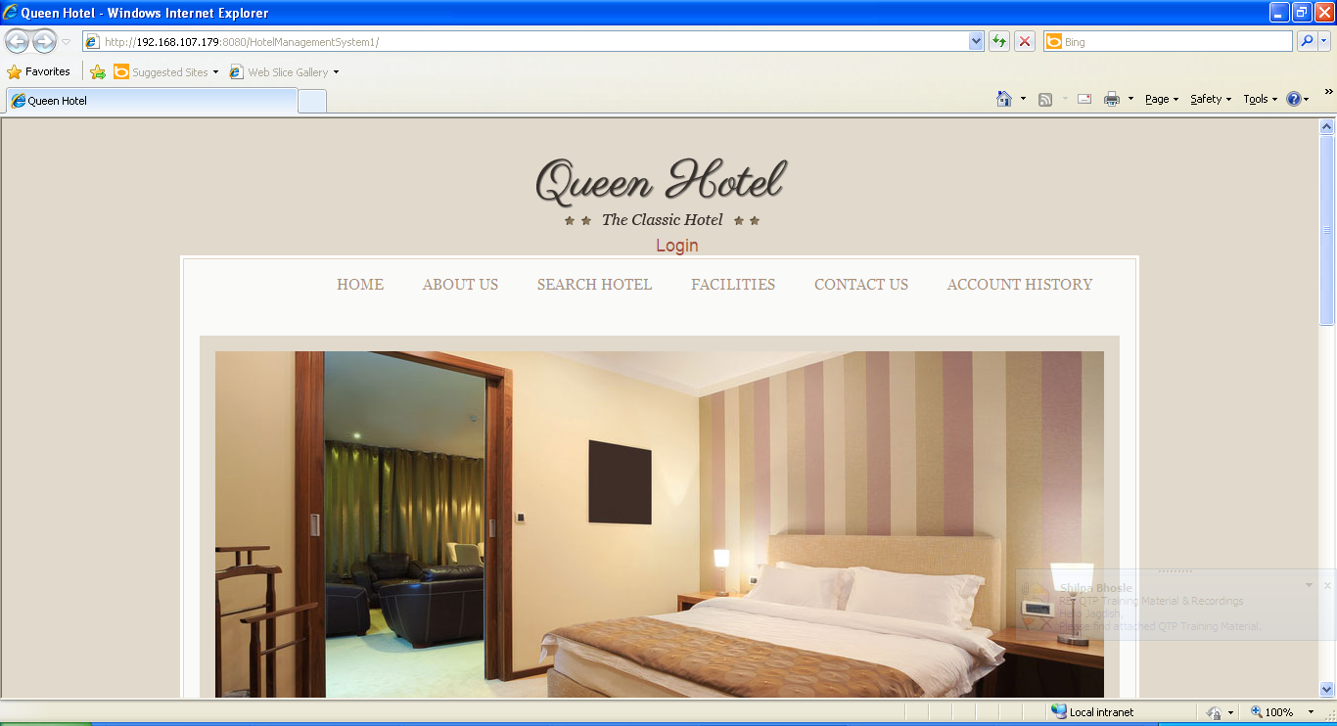

- Login Screen: Allows the valid user or amount to logon to the system and display the Main option screen.

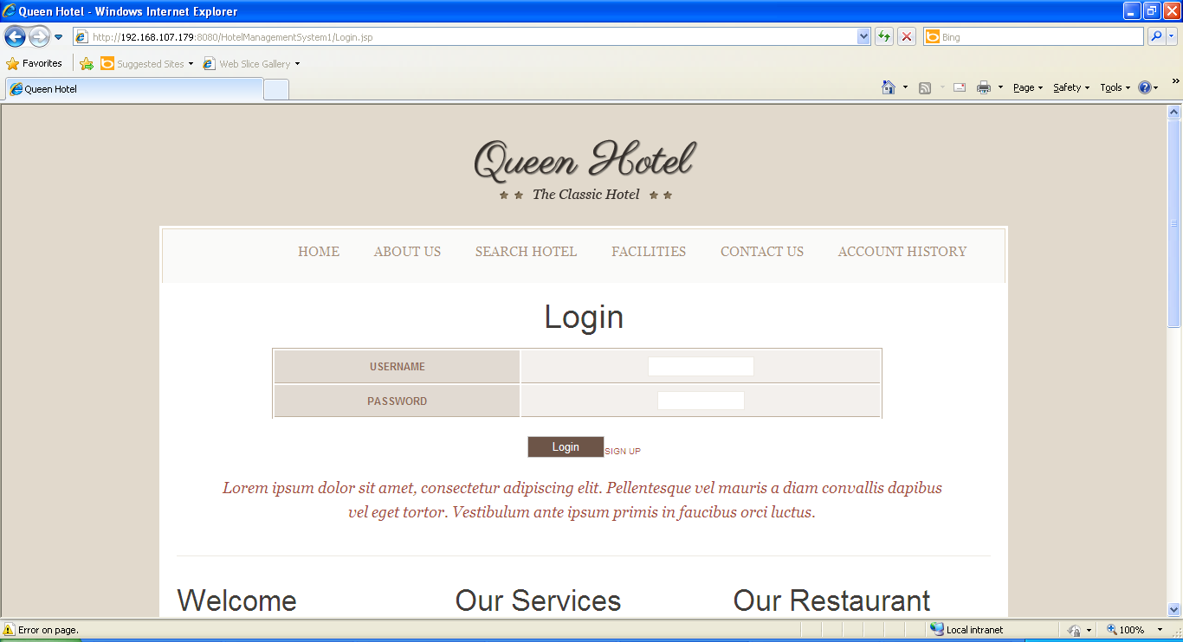

- View Hotel screen: For all the users, this screen shows a list of hotels and rooms.

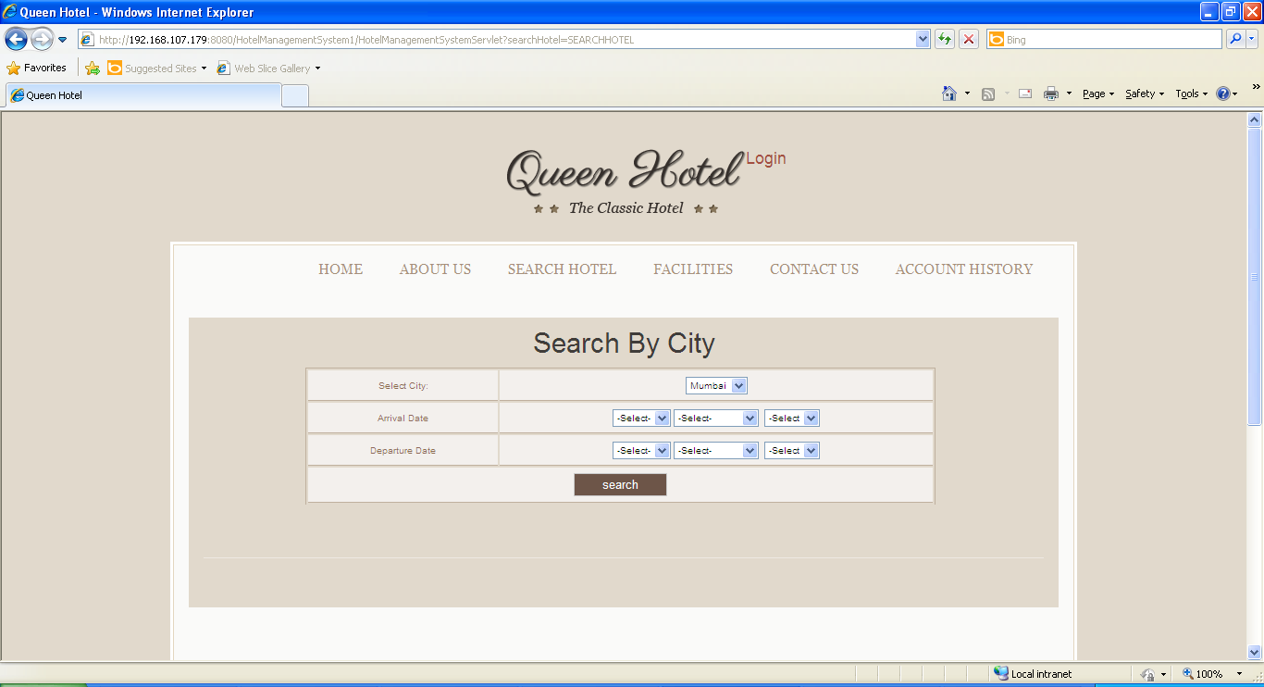
- Book Rooms: For the customers and the hotel-employees, this screen will allow booking of available hotel rooms.

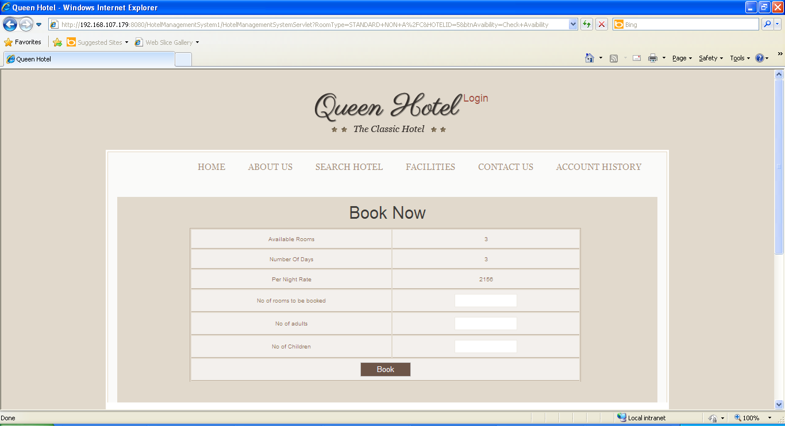

- Add Hotels: This screen allows the admin to add new hotels or rooms.

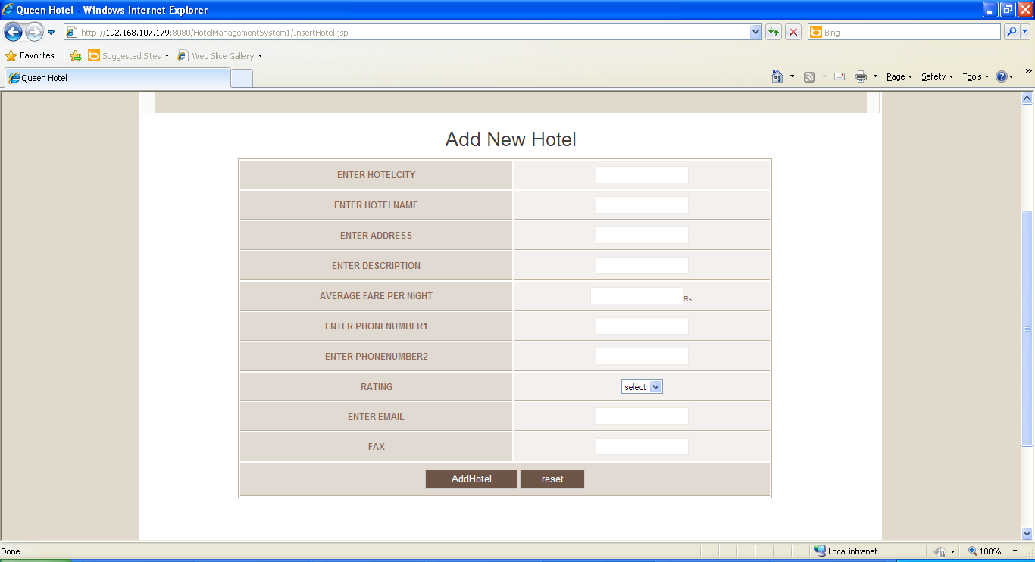
- Update Hotels: This screen allows the admin to update existing hotels or rooms.

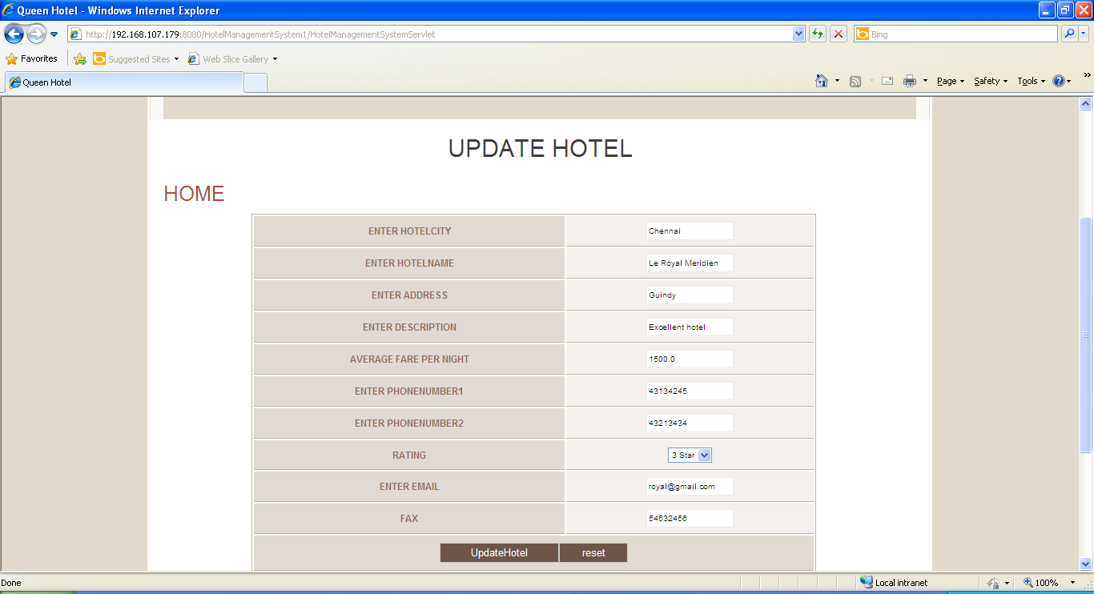

- Delete Hotels: This screen allows the admin to delete existing hotels or rooms.
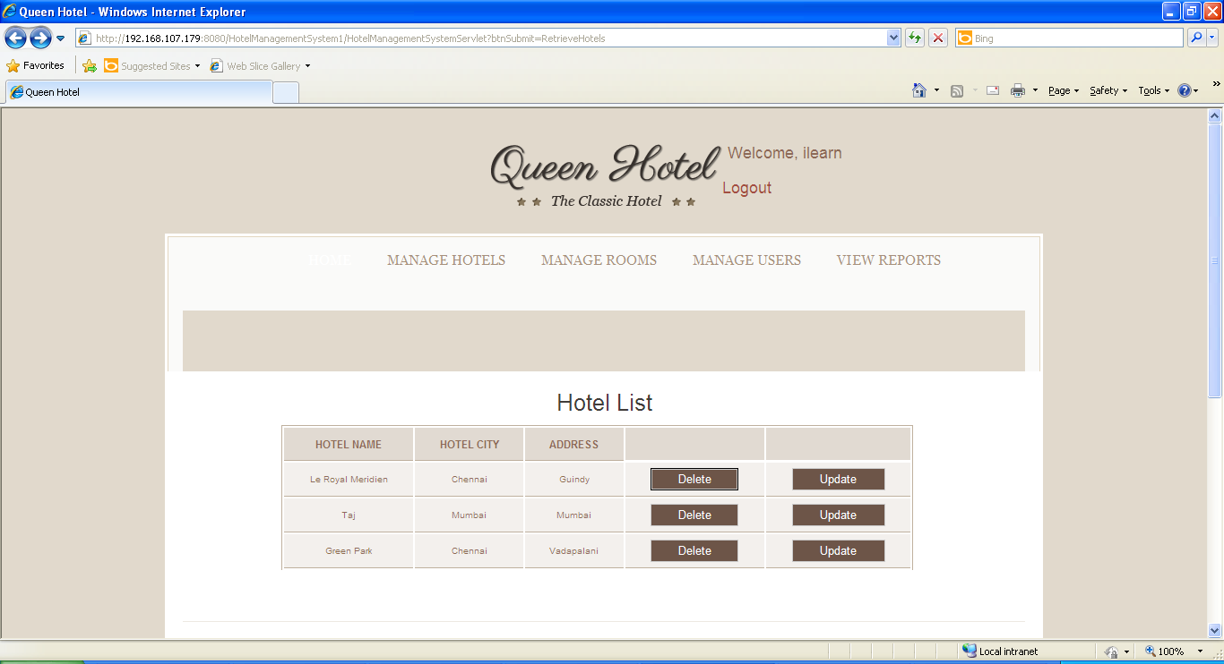

- View Reports: This screen offers administrator to view various reports by clicking on an appropriate link.
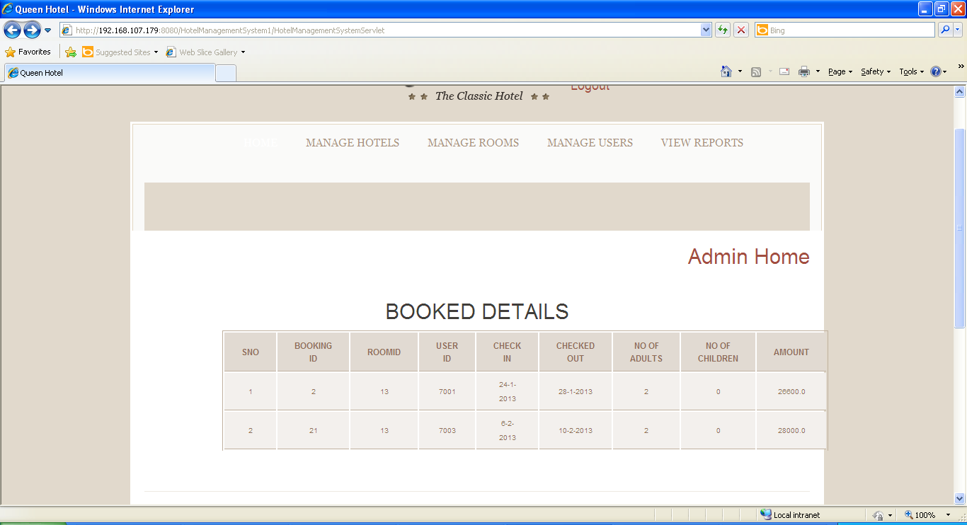

- Test all other screens and links that appear in the application for admin, Employee and Customer.

- Test the business components for the following functionality:
- User verification: (on Login) This component will verify if the user who is trying to access the system is a valid user. This verification is as against the valid users listed in the users table.
- Add/Delete/Modify: This component will allow the admin to add new hotels, update and delete existing hotels.
- Book Rooms: this component will allow the customers to book rooms.

Project Evaluation Guidelines
The project it is to be evaluated based on the following five parameters:

- Requirements Itemization (20 Marks)
  - Categorizing & writing requirements appropriately in the RVFD template.
  - Setting the appropriate priority for the requirements.
- Use Case (20 Marks)
  - Identifying correct Use Cases and creation of the same.
- Using TBA template to write test cases (20 Marks)
  - Effective Test Case writing using TBA template with appropriate input data, expected result & actual result.
  - Creating scenario matrix, use case level test cases, form level test cases, field level test cases, error table etc.
- Creation of defect report (20 Marks)
  - Writing defect free defects in the defect log
- Adherence to guidelines & complete solutions (10 Marks)
  - The participants needs to ensure that each & every artifact created during Mini Project activity should follow all the guidelines & best practices shared & taught during the training.
  - They also need to take care that all the expectations set for the successful completion of Mini Project are taken care of.
- Group Presentation and Query handling – (10 Marks)
  - Each participant is expected to present the Mini Project as a part of the group and as per the division of the responsibility/modules.
  - They are expected to handle the queries asked during the presentation in a satisfactory manner.

